New Zealand Myrtle Rust Monitoring Form

This form has been designed for use by trained myrtle rust observers and can be completed on paper or digitally using a tablet (or another electronic device).
The unit of interest is an individual plant or stand of small trees/shrubs or a hedge of the same species with overlapping foliage and cannot be easily distinguished as an individual plant. Any seedlings of these plants should be included in the unit of interest and recorded on the same form as the adult plant or stand. It is extremely valuable to know where, and on which hosts, myrtle rust is present. It is also extremely valuable to know where, and on which hosts, myrtle rust IS NOT PRESENT.
Please complete all relevant fields each time you monitor, regardless of myrtle rust presence or absence.
What we define as a myrtle rust positive site:
Confirmed host identification by a trained observer, OR expert confirmation of a submitted photo of the host,
AND,
Confirmed observation of myrtle rust symptoms by a trained observer, OR expert confirmation of a submitted photo of suspect myrtle rust symptoms on a host.

How to fill in the form
The first time you visit a site complete the site description on page two. You will only need to do this once.
Fill in page 3 at least once a year for an annual monitoring.
Fill in the rest of the form each you come back to a site to monitor the same plant.
Use separate forms to record results for different host species in the same stand or hedge.

How to submit photos to confirm the plant species identity and/or myrtle rust infection
Please submit photos through the Myrtle Rust Reporter project on iNaturalistNZ:
https://inaturalist.nz/projects/myrtle-rust-reporter

Completed forms can be submitted
Users can either hold their own data or send through the form (directly or scanned) to the following email address:

Roanne.Sutherland@scionresarch.com
Data from any forms sent will be added to a national database when established.

SITE DESCRIPTION

Date (dd/mm/yyyy):______/_____/______ Observer name(s): ___________________________________
Contact phone: ______________________________ and/or email: _________________________________
Individual plant (or stand/hedge) identifier code ______________________
(This can be created by using the first 2 letters of the location and plant number e.g. Whakatane plant 2 would be WH02)

If this section has been completed previously, please go to the Regular Plant Description section.
GPS coordinates: North: ___________________ East: ___________________ (NZTM 2000 recommended)
Or Lat: ____________________ Long: _____________________
Or address: _______________________________________________________
________________________________________________________

Describe the area where
the plant(s) is/are located
and how to find the plant(s):
(double click in the box)

Habitat: tick all that apply
Native forest | ☐ |  | Riparian | ☐
Commercial plantation | ☐ |  | Scrubland | ☐
Urban | ☐ |  | Reserve (park or fields) | ☐
Rural | ☐ |  | Urban street planting | ☐
Wetland | ☐ |  | Garden (home, school, business) | ☐
Coastal | ☐ |  | Farmland | ☐
Botanic garden | ☐ |  | Lake side | ☐
Orchard | ☐ |  | Natural | ☐
Nursery | ☐ |  | Planted | ☐
Roadside | ☐ |  | other____________________________ | ☐

Site owner has given permission to add data to the National MR database: No ☐ Yes ☐

Land ownership (if known)
Māori title land | ☐
DOC managed | ☐
Territorial authority managed/owned | ☐
Private owner | ☐
Other | ☐

PLANT DESCRIPTION
Monitored plant(s) identification (See Appendix 1):
Common/Māori name: _________________________________________
Genus: ______________________________________________________
Latin species name (if known): ___________________________________________________
Confidence level of host species identification: very confident ☐ confident ☐ not confident ☐
Marking the Plant(s)
If this plant (or plants) will be regularly monitored, ensure that you are able to locate them easily. One way is the use of flagging tape with the individual plant identification number on, or another identifier that can be removed without damaging the plant.

Unit of interest being monitored:
1 plant ☐ stand of small trees/shrubs ☐ hedge ☐
Monitored plant(s) height (in metres):
0-1 m ☐ 1-5 m ☐ 5-10 m ☐ >10 m ☐
Location of the monitored plant(s) within the forest structure):
Not in a forest | ☐
Seedling | ☐
Understory | ☐
Canopy | ☐
Emergent tree | ☐

Population size:
Number of mature plants (i.e. greater than 30 cm in height) of the same plant species present  (within 3 m radius): |  | Number of seedlings (i.e. under 30 cm in height) of the same plant species present  (within 3 m radius)
0 | ☐ | 0 | ☐
1-10 | ☐ | 1-10 | ☐
10-25 | ☐ | 10-25 | ☐
More than 25 | ☐ | More than 25 | ☐

Other myrtle species present within 3 m radius: No ☐ Yes ☐ (See Appendix 1):
If yes what species_______________________________________________________

General comments on the plant(s) (optional)

REGULAR PLANT DESCRIPTION

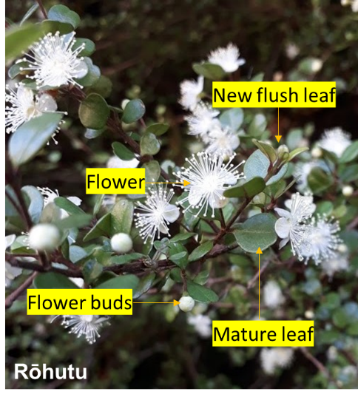
Monitored plant growth (see Appendix 2)
Which plant parts can you observe?
New flush leaves | No ☐ Yes ☐
New flush stems | No ☐ Yes ☐
Flower buds | No ☐ Yes ☐
Flower | No ☐ Yes ☐
Immature fruits | No ☐ Yes ☐
Mature fruits | No ☐ Yes ☐
Mature leaves | No ☐ Yes ☐

Foliage light exposure of the monitored plant(s):
Full light in the open (100% light) | ☐
Partial shade (50% light) e.g. forest margin | ☐
Low light under canopy (less than 10% light) | ☐

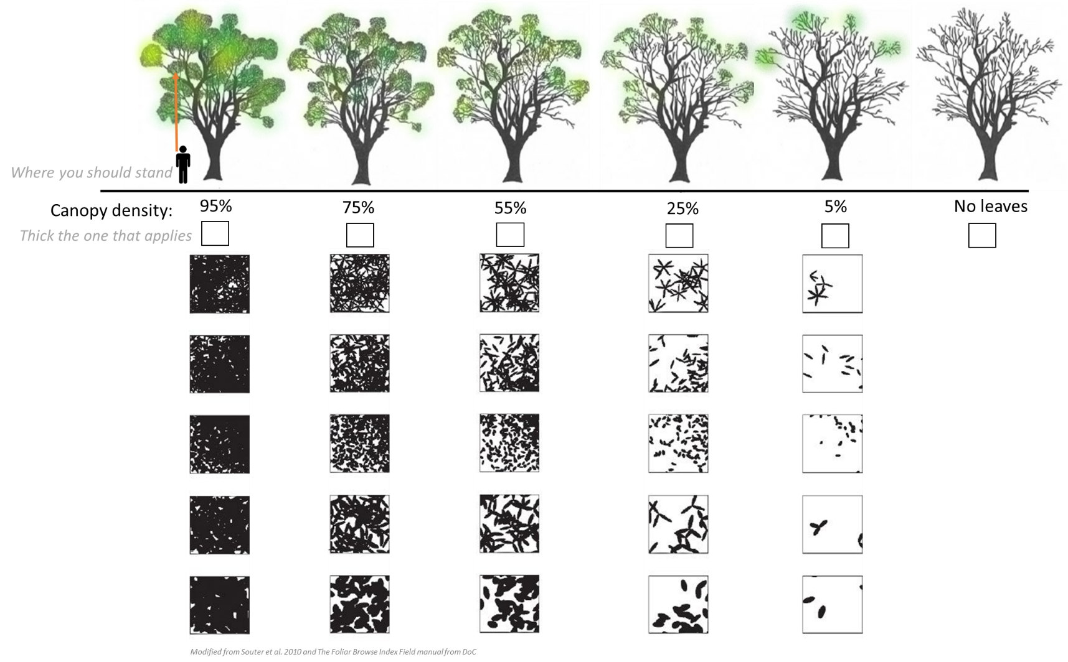
Canopy density of the monitored plant from standing directly underneath the tree. This does not include other plant species that are part of the forest canopy or small trees.

Photo:
A photo of the plant(s) has been taken. Yes ☐
What is the photo file name? ______________________________
Have you taken a close-up photo of the leaves: No ☐ Yes ☐
If yes, what is the photo file name? ______________________________

OTHER ENVIRONMENTAL DISTURBANCES
From the monitored plant(s), do you see:

Evidence of mammalian browsing No ☐ Yes ☐ Don’t know ☐
Insect browsing No ☐ Yes ☐ Don’t know ☐
Other leaf spots No ☐ Yes ☐ Don’t know ☐
Poor drainage / wet feet No ☐ Yes ☐ Don’t know ☐
Other ill health: _________________________________________________
If you are in a natural ecosystem, describe the general health around the monitored plant(s) (optional):

Evidence of recent site disturbance (i.e new since the last time that you monitored the plant(s)):
No new evidence of disturbance No ☐ Yes ☐ Don’t know ☐
Fire No ☐ Yes ☐ Don’t know ☐
Windfall No ☐ Yes ☐ Don’t know ☐
Slips/land slide No ☐ Yes ☐ Don’t know ☐
Track maintenance No ☐ Yes ☐ Don’t know ☐
Pruning of hosts No ☐ Yes ☐ Don’t know ☐
Animal disturbance No ☐ Yes ☐ Don’t know ☐
Evidence of animal pest control No ☐ Yes ☐ Don’t know ☐
Evidence of weed spray No ☐ Yes ☐ Don’t know ☐
Mowing No ☐ Yes ☐ Don’t know ☐
Other disturbances _____________________________________________________

MYRTLE RUST DISEASE SEVERITY ASSESSMENT

Myrtle rust observer training type: CRI ☐ Territorial authority ☐ DOC ☐ TTW ☐ Iwi ☐
AsureQuality/MPI response training ☐ MPI Myrtle rust online learning modules ☐ Not trained ☐ Self-trained ☐ Other, specify: _______________________

Weather condition during the observation: Sunny ☐ Overcast ☐ Rainy ☐
Plant(s) infection status:
infected ☐ not detected ☐ suspect myrtle rust to be present ☐

STOP HERE IF NO MYRTLE RUST –
CONTINUE IF MYRTLE RUST IS PRESENT OR SUSPECTED TO BE PRESENT

Which plant parts are showing myrtle rust symptoms?
 | Myrtle rust symptoms
New flush leaves | No ☐ Yes ☐ suspect ☐
New flush stems | No ☐ Yes ☐ suspect ☐
Flower buds | No ☐ Yes ☐ suspect ☐
Flowers | No ☐ Yes ☐ suspect ☐
Immature fruits | No ☐ Yes ☐ suspect ☐
Mature fruits | No ☐ Yes ☐ suspect ☐
Mature leaves | No ☐ Yes ☐ suspect ☐

Are the same host species within 3 m radius infected: No ☐ Yes ☐ Suspect ☐ Are there other myrtle species within 3 m radius infected: No ☐ Yes ☐ Suspect ☐
If yes, what species? (See Appendix 1):

MYRTLE RUST DISEASE SEVERITY ASSESSMENT

Percent of plant (s) visually observed: 1-25% ☐ 25-50% ☐ 50-75% ☐ 75-100% ☐

Percent of plant part with symptoms (see Appendix 2):

 | 0 | 1 | 2 | 3 | 4
Plant parts | None are infected (0%) | 1-10 are infected  (1-10%) | Up to half are infected  (10-50%) | More than half are infected (50-80%) | Almost all are infected  (80-100%)
New flush leaves | ☐ | ☐ | ☐ | ☐ | ☐
New flush stems | ☐ | ☐ | ☐ | ☐ | ☐
Flower buds | ☐ | ☐ | ☐ | ☐ | ☐
Flowers | ☐ | ☐ | ☐ | ☐ | ☐
Immature fruits | ☐ | ☐ | ☐ | ☐ | ☐
Mature fruits | ☐ | ☐ | ☐ | ☐ | ☐
Mature leaves | ☐ | ☐ | ☐ | ☐ | ☐

Lesions and spores:

Red spots No ☐ Yes ☐
Yellow spores (Urediniospores) No ☐ Yes ☐
Grey (Old spores) No ☐ Yes ☐
*Dark brown spores (Teliospores) No ☐ Yes ☐ Don’t have a microscope ☐
*can only be confirmed under microscope
Other Myrtle rust related symptoms: | Browning and curling leaves or shoots | No | ☐ | Yes | ☐
 | Defoliation/Leaf loss | No | ☐ | Yes | ☐

Myrtle rust related dieback: | 0% ☐ | 1-10% ☐ | 10-50% ☐ | 50-80% ☐ | 80-100%  ☐ | Entire plant dead ☐

Photo
A photo of the myrtle rust infection on the plant has been taken: Yes ☐
What is the photo file name: ______________________________

General comments on the infection (optional)
MYRTLE RUST DISEASE SEVERITY ASSESSMENT

- Severity score modified from Pegg et al., 2012:
Pick a score for assessing the disease severity according to your previous observations in the form.
*Plant parts refers to stem, leaf, flowers, buds and fruits.
Score |  | Symptom Description
☐ | 0 | no evidence of myrtle rust symptoms
☐ | 1 | minor leaf spots with myrtle rust pustules on <10% of plant parts, only a few pustules per infected plant parts
☐ | 2 | myrtle rust pustules present on 10-50% of plant parts, moderate number of pustules per infected plant part
☐ | 3 | myrtle rust pustules present on 50-80% of plant parts, multiple pustules per plant part, blighting and distortion (curly)
☐ | 4 | myrtle rust present on the majority of plant parts, multiple pustules per infected plant part, foliage dieback, evidence of stem and shoot dieback

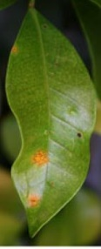
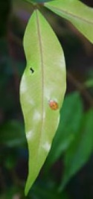

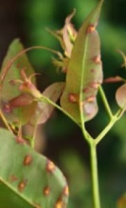
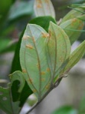

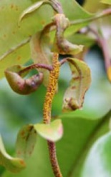
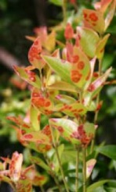

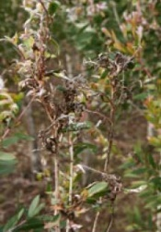
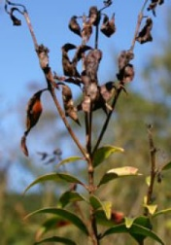

MYRTLE RUST MANAGEMENT
Have you managed the infected plant(s) (e.g. pruning, spray or plant removal)?
No ☐ Yes ☐

If yes, please specify: _________________________________________________

Are you intending to actively manage the infected plant? No ☐ Yes ☐

If yes, what do you intend to do: _________________________________________

Scientific name | Common name | Native /non-native
Acca sellowiana | feijoa | Non-native
Agonis flexuosa | willow myrtle | Non-native
Callistemon sp. | bottlebrush | Non-native
Corymbia sp. | gums, eucalpyts | Non-native
Eucalyptus globoidea | stringy bark eucalpyt | Non-native
Eucalyptus sp. | eucalpyts | Non-native
Kunzea amanthicola | sand kānuka; rauwiritoa | Native
Kunzea ericoides | manuoea, titira, atitira, kanuka | Native
Kunzea linearis | northern kānuka; rauwiri | Native
Kunzea robusta | lowland kānuka; rauwirinui | Native
Kunzea salterae | Moutohorā kānuka | Native
Kunsea serotina | upland kānuka ; mākahikātoa | Native
Kunzea sinclairii | Barrier kānuka | Native
Kunzea tenuicaulis | geothermal kānuka | Native
Kunzea toelkenii | Bay of Plenty kānuka | Native
Kunzea triregensis | Three Kings kānuka | Native
Leptospermum.scoparium | Mānuka | Native
Lophomyrtus bullata | ramarama, bubble leaf | Native
Lophomyrtus obcordata | rōhutu | Native
Melaleuca sp. | bottlebrush | Non-native
Metrosideros albiflora | kauri rātā vine; akatea | Native
Metrosideros bartlettii | Bartlett’s rātā; rātā moehau | Native
Metrosideros carminea | carmine rātā vine | Native
Metrosideros colensoi | pendant rātā vine | Native
Metrosideros diffusa | white rātā vine | Native
Metrosideros excelsa | pōhutukawa | Native
Metrosideros fulgens | scarlet rātā vine | Native
Metrosideros kermadecensis | Kermadec pōhutukawa | Native
Metrosideros parkinsonii | crimson rātā | Native
Metrosideros perforata | small white rātā vine | Native
Metrosideros robusta | northern rātā | Native
Metrosideros umbellata | southern rātā | Native
Myrtus communis | common myrtle | Non-native
Neomyrtus pedunculata | rohutu | Native
Syzygium australe | lilly pilly | Non-native
Syzygium maire | swamp maire; maire tawake | Native
Thryptomene calycina | Grampians heath myrtle | Non-native
Ugni molinae | Chilian guava, NZ cranberry | Non-native

Appendix 2: Plant development stage and myrtle rust symptoms

Plant development stages
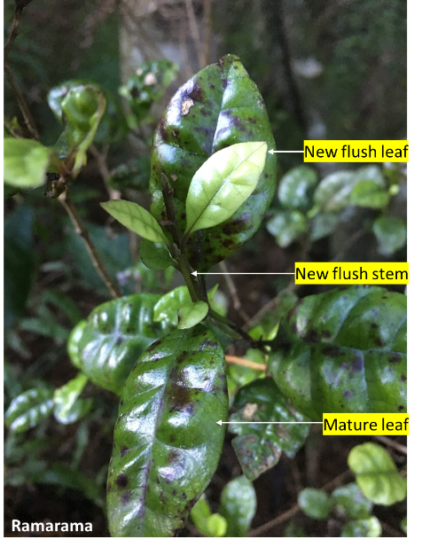
New flush leaves or stem: new young growth, soft to touch, lighter in color, leaf size ranges from small to same size as fully developed leaves.
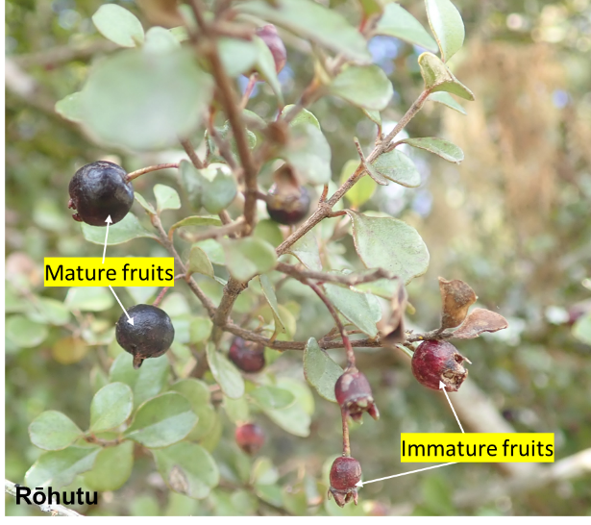
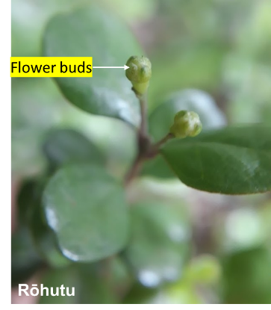
Mature fruit: fully developed fruit or mature seed capsules.
Flower buds: developing flowers surrounded by sepals.

Immature fruit: early stage development of fruits, when the flower part is no longer present (stamen, petals, pistil).

Mature leaves. fully developed leaves that are darker in colour and firmer to touch than the new flush leaves.

Myrtle rust symptoms
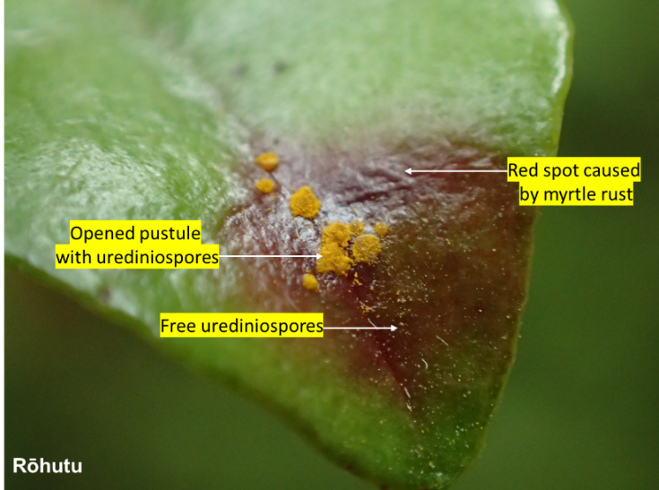
Red spot: red-purple lesion, general plant reaction to biotic stress (e.g. insect, pathogen), this can be the first sign of myrtle rust infection.
Yellow spores (Urediniospores): yellow myrtle rust spores present inside a pustule. Spores disperse widely when the pustule erupts.
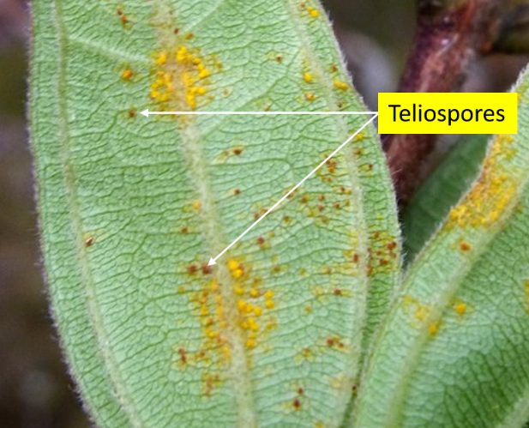
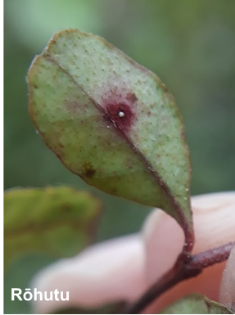
Grey (Old spores): old yellow myrtle rust spores that have lost their pigments.

Dark brown spores (Teliospores): next stage of myrtle rust spore cycle, brown coloured, may also occur with yellow myrtle rust spores.

Additional resources on myrtle rust identification can be found on https://www.myrtlerust.org.nz/
CREDITS

This form was designed as part of the Ministry for Primary Industries commissioned research project MPI18607. The content of the form was developed by Roanne Sutherland, Julia Soewarto, Karyn Froud and Rebecca Ganley with the contribution of mana whenua, Department of Conservation, regional and district councils, industry representatives, private land owners, public and staff from research organisations who have assisted in the development and testing of the form.

